

4ID3 - IoT Devices and Networks

Lab 5

Communicating Sensor Data over a ZigBee Network

Adam Sokacz, Ishwar Singh, and Salman Bawa

Sponsored by [*Future Skills Center, Canada*](https://fsc-ccf.ca/) and[*McMaster W Booth SEPT*](https://www.eng.mcmaster.ca/sept)

Group Number:

Name, Student Number:

Name, Student Number:

Name, Student Number:

Submission Date:

# Objective

In this lab, sensor data will be collected on a node in the ZigBee network. This data will be passed on to the controller node while the devices are in API mode. Once at the controller, it will be communicated to the PC using wired serial communication, and aggregated into a database.

Contents

Objective 2

Feedback 3

Additional Resources 3

Pre-Lab Questions 4

Post-Lab Questions 4

Exercise A Results: 6

Exercise B Results: 6

Exercise C Results: 6

Project Setup 7

Installing XCTU 8

Connecting and Updating the XBee3 Modules 10

Configuring Boards using XCTU 14

Transparent Mode 16

API Mode 20

GPIO Forwarding 27

Connections 27

Python script setup 29

Exercise A 35

Exercise B 35

(Optional) Exercise C 36

Syncing with GitHub 38

# Feedback

Q1 - What would you rate the difficulty of this lab?

*(1 = easy, 5 = difficult)*

|  |  |  |  |  |
| --- | --- | --- | --- | --- |
| **1** | **2** | **3** | **4** | **5** |

Comments about the difficulty of the lab:

Q2 - Did you have enough time to complete the lab within the designated lab time?

|  |  |
| --- | --- |
| **YES** | **NO** |

Q3 - How easy were the lab instructions to understand?

*(1 = easy, 5 = unclear)*

|  |  |  |  |  |
| --- | --- | --- | --- | --- |
| **1** | **2** | **3** | **4** | **5** |

List any unclear steps:

Q4 - Could you see yourself using the skills learned in this lab to tackle future engineering challenges?

*(1 = no, 5 = yes)*

|  |  |  |  |  |
| --- | --- | --- | --- | --- |
| **1** | **2** | **3** | **4** | **5** |

# Additional Resources

**Lab GitHub Repo** ( <https://github.com/sokacza/4ID3> )

MySQL Basics ( <https://youtu.be/Cz3WcZLRaWc> )

NodeRED Fundamentals Tutorial ( <https://youtu.be/3AR432bguOY> )

# Pre-Lab Questions

Q1 - Name **6** advantages of ZigBee over other **access technologies**.

(Suggested: List)

Q2 – ZigBee devices operate as a **mesh network**. Draw the mesh network topology using **4 devices.**

(Suggested: Sketch)

Q3 - ZigBee builds on the IEEE standard **802.15.4** physical layer. What layer of the **ISO model** does ZigBee operate in?

(Suggested: Sentence)

Q4 – Since ZigBee networks ping data across many devices, what **security features** are built into ZigBee to prevent data from being exposed with malicious intent?

(Suggested: List)

Q4 – In documentation, you may hear the terms **XBee** and **ZigBee** being used **interchangeably**. What is the **difference** between these two terms?

(Suggested: A few sentences)

# Post-Lab Questions

Q1 - Draw a **diagram** to identify **each component** of the IoT network produced in this lab and describe the **information being exchanged** between the components.

(Suggested: Sketch)

Q2 – There are **3** types of XBee devices: **Coordinators**, **Routers**, and **End Devices**. In a table, compare and contrast the role of each category of device in the ZigBee network.

<https://www.digi.com/resources/documentation/Digidocs/90001942-13/>

(Suggested: Table)

Q3 – **AT commands** are typically used when communicating with low-level **embedded** devices such as **communication modules**, especially for **device configuration**. Using page **40** in the **product manual**, describe how the AT commands for this product are **structured**. Relate AT commands with what happens when you press **write setting** in the **XCTU** XBee software?

<https://www.digi.com/resources/documentation/Digidocs/90001942-13/>

(Suggested: Paragraph)

Q4 – There are **two operating modes** for these XBee3 units: **API** and **Transparent**. Using the manual, research each of these modes and compare and contrast **3** points of each in a **table**.

<https://www.digi.com/resources/documentation/Digidocs/90001942-13/>

(Suggested: Table)

Q5 – The END_DEVICE publishes the message **GPIO4 ON** to the network address **00 00 00 00 00 00 00**. The ROUTER device is just within range of the END_DEVICE, and the COORDINATOR is just within range of the ROUTER. The END_DEVICE is out of range of the COORDINATOR. Which device(s) receives the message? Explain why?

(Suggested: Paragraph)

Q6 - You are tasked with making a desktop application that has a user log in. The username and password are stored in a MySQL database. Investigate the topic of password hashing:

<https://youtu.be/cczlpiiu42M>

**Write** and execute a **Python script** that hashes the following password:

*Password:* *9055259140*

<https://www.geeksforgeeks.org/how-to-hash-passwords-in-python/>

Paste a screenshot of your terminal output:

**Write** a **MySQL query** to **insert** the hashed password into the following database:

|  |  |
| --- | --- |
| **Accounts** | |
| Email | Password |
| test@example.com | <Your password hash> |

Q7 - What is the difference between **hashing** and **encryption**? Write and execute a **python script** to **encrypt** and **decrypt** the following string:

message = “ { \“GroupA\”: { \“DeviceA\”: { \“Temperature\”: 23.9 } } } “

<https://www.geeksforgeeks.org/how-to-encrypt-and-decrypt-strings-in-python/>

Paste a screenshot of your terminal output:

Q8 - Write a brief LinkedIn post about **4** **key learning takeaways** from this lab.

(Suggested: Short paragraph)

# Exercise A Results:

# Exercise B Results:

# Exercise C Results:

# Project Setup

Issue the following commands from the root directory of your existing local repository for this class:

*git pull origin main*

<Create your folders and README.md file>

*git add .*

*git commit -m “lab 6”*

*git push origin main*

# Installing XCTU

Navigate to the following URL and install the XCTU XBee3 configuration utility:

<https://www.digi.com/products/embedded-systems/digi-xbee/digi-xbee-tools/xctu#productsupport-utilities>

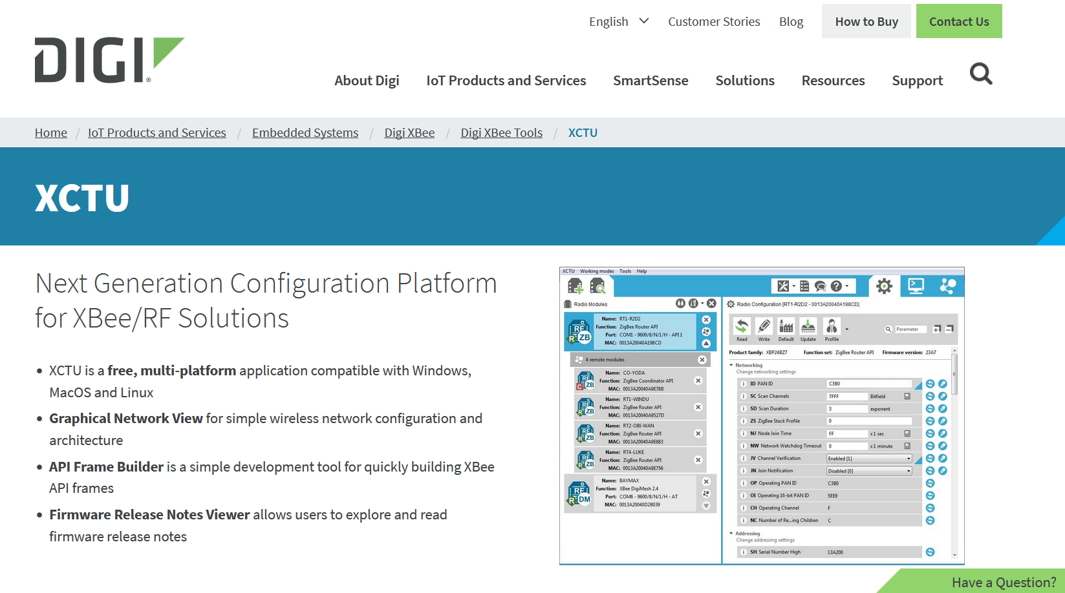

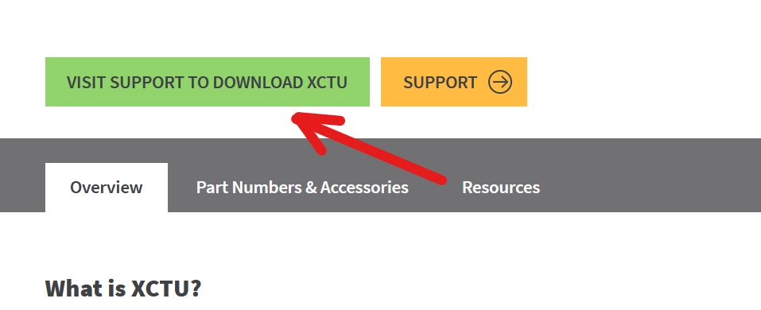

Install both the utility and drivers for your PC. Select **Add Drivers to Windows** when prompted.

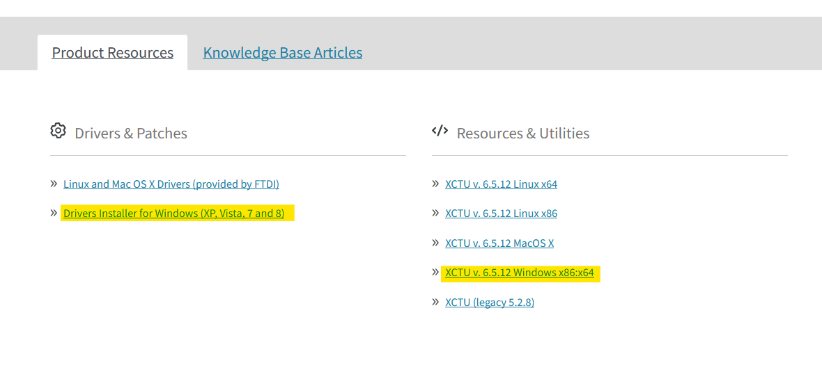

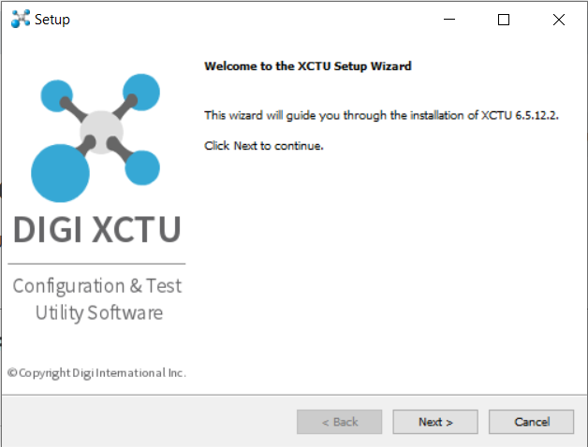

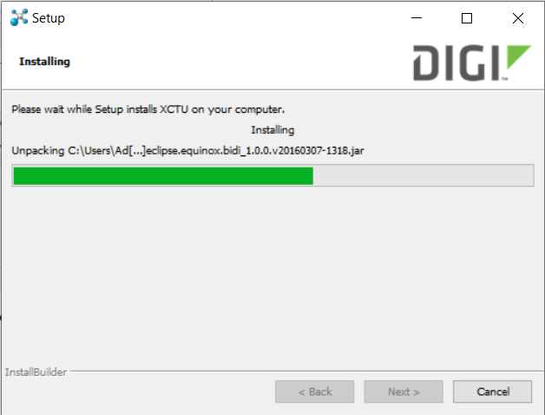

Once installed, **restart** your PC.

# Connecting and Updating the XBee3 Modules

Open the XCTU XBee3 configuration utility.

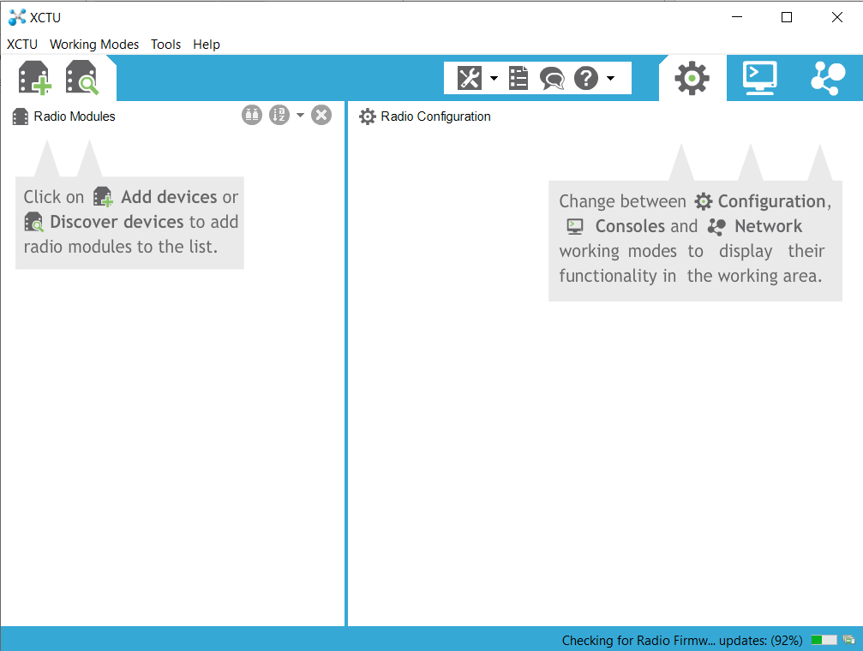

Plug in your XBee devices

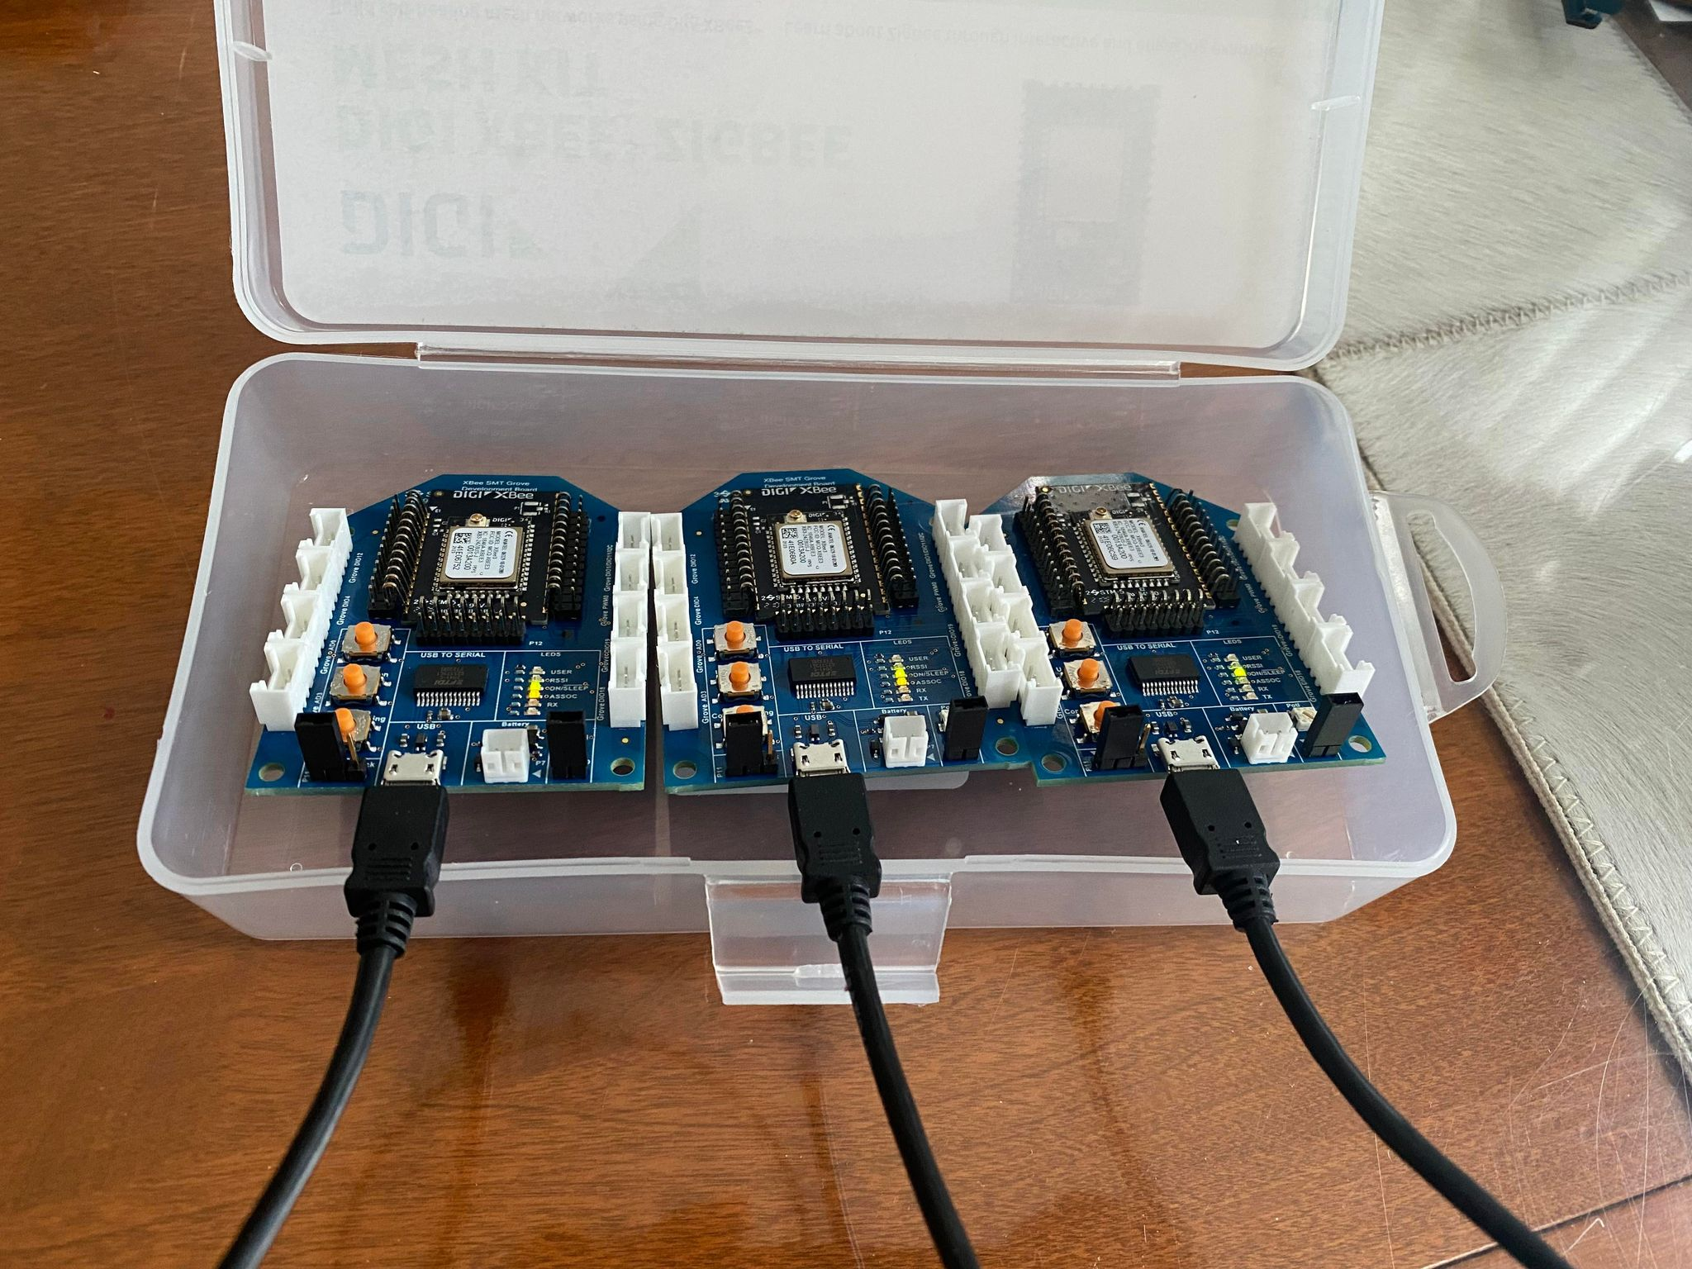

Connect the devices using the **Device Search** button on the **top toolbar**.

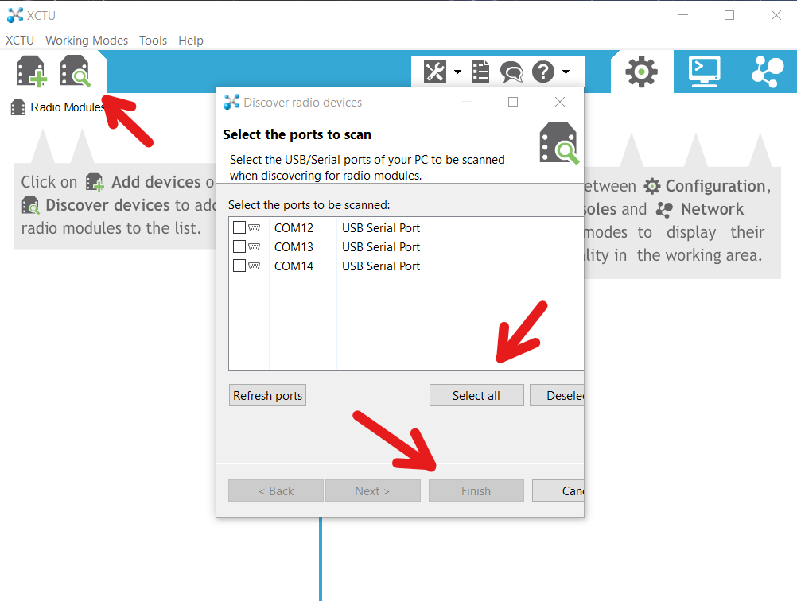

Use **default** parameters when prompted and add each of your **COM** devices.

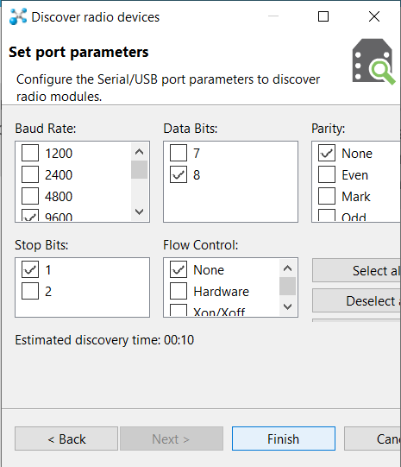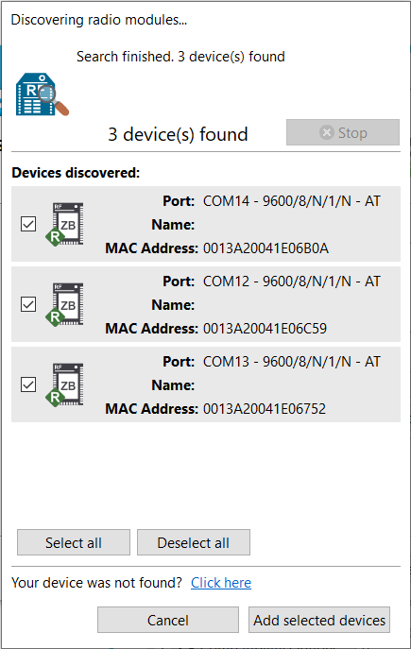

You may see a **new firmware** prompt above each device. If so, update the firmware of each development board to the latest version.

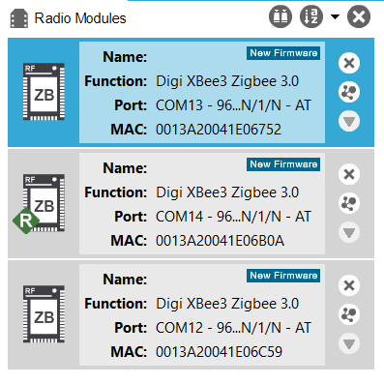

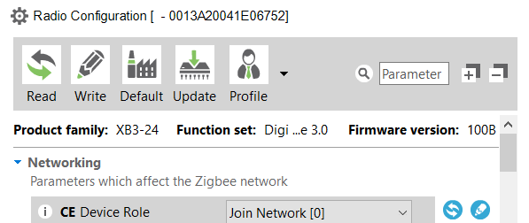

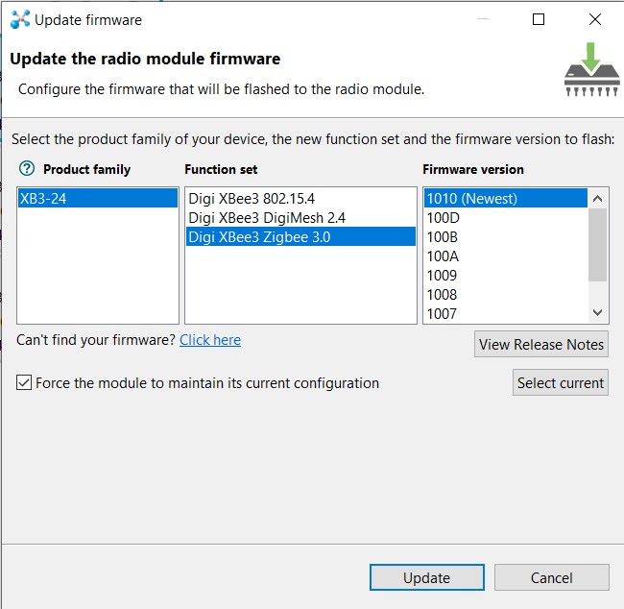

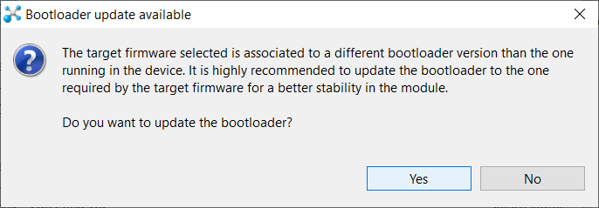

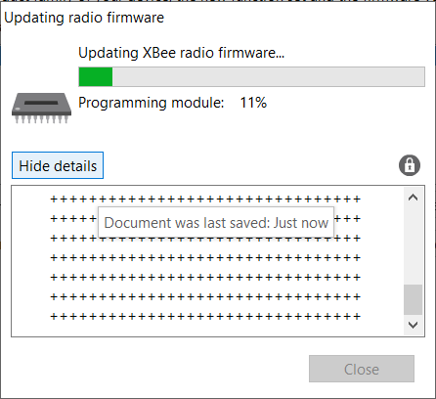

# Configuring Boards using XCTU

Use the **Load Default Firmware** to reset the configuration of each device.

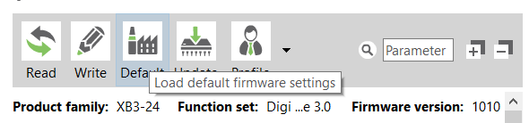

Following the table below, configure each device. ( -- symbol means leave default)

**USE A UNIQUE ID VARIABLE THAT IS THE SAME FOR EACH NODE IN YOUR NETWORK.**

|  |  |  |  |  |
| --- | --- | --- | --- | --- |
| **Device Setup** | | | | |
| Parameter | XBee A  (Coordinator) | XBee B  (Router) | XBee C  (End Device) | Effect |
| **ID** | 123 | 123 | 123 | Network ID |
| **JV** | — | Enabled [1] | Enabled [1] | Join or become coordinator |
| **CE** | — | — | — | Force as coordinator |
| **DH** | — | 0 | 0 | Destination address (high) |
| **DL** | — | 0 | 0 | Destination address (low) |
| **NI** | COORD | ROUTER | END_ DEVICE | Node name |
| **SP** | 1F4 | 1F4 | 1F4 | Sleep time = 1F4 (hexadecimal) = 500 (decimal) x 10 ms = 5 seconds. |
| **SM** | — | — | Cyclic sleep [4] | Sleep setting (only end devices sleep) |
| **SO** | — | — | 2 | Keep awake |

There are 2 ways to write configurations:

1. Write all configurations

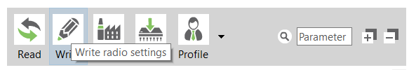

1. Write individual configuration

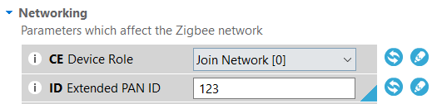

Once all of these configurations are changed and written to each XBee module, we will attempt to transmit data using **transparent mode** from the **router** to the **coordinator**.

# Transparent Mode

In one **console** window, open the **COORD** device.

In another **console** window, open the **ROUTER** device.

Type **Hello World!** into the **ROUTER** console window.

The data should print in the **COORD** window.

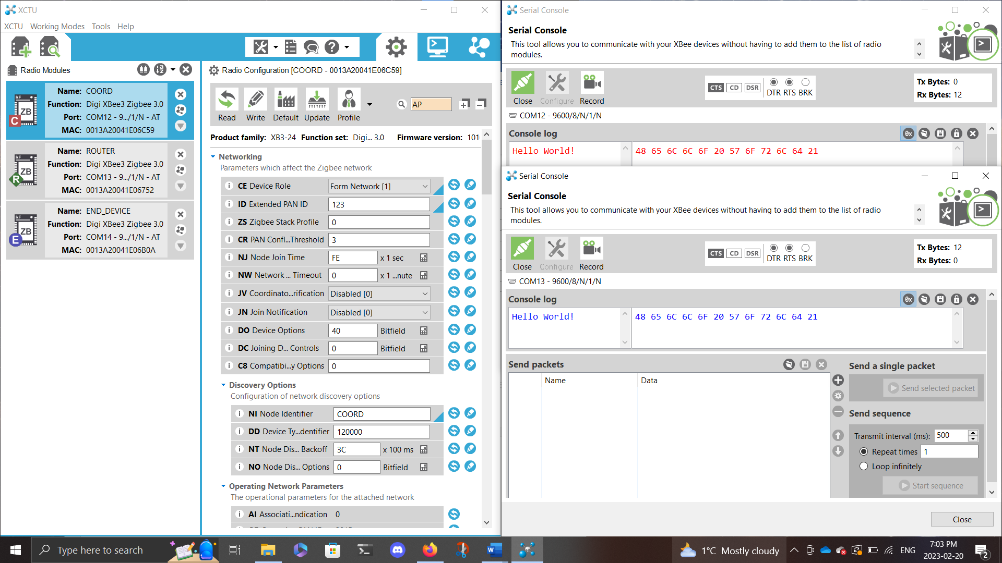

Next, type **Yo!** into the **END_DEVICE** console window.

The data should print in the **COORD** window.

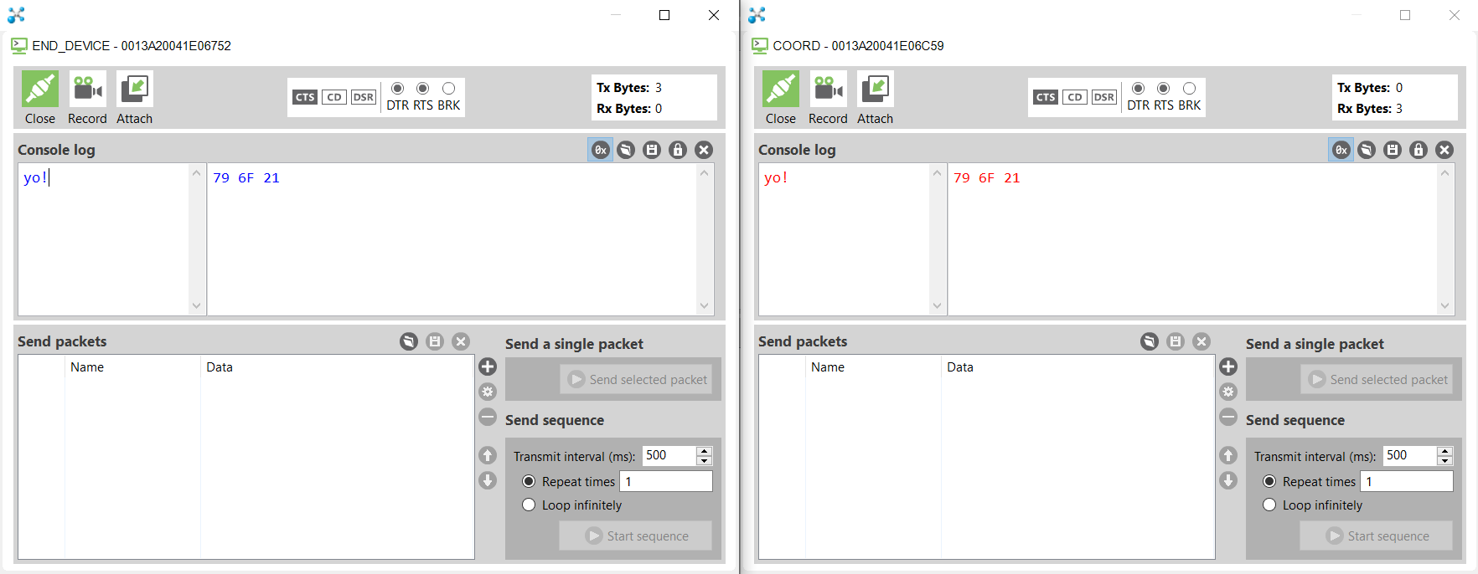

Create a new folder in your lab folder called **Lab05A_TransparentMode**.

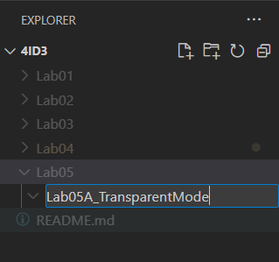

In XCTU, for each device, select **Profile > Create Profile.**

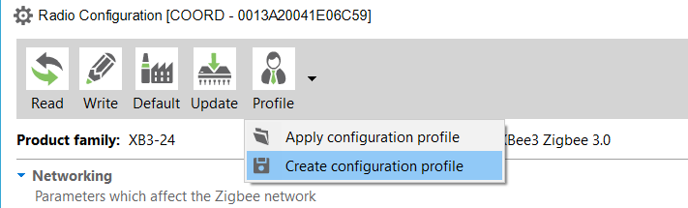

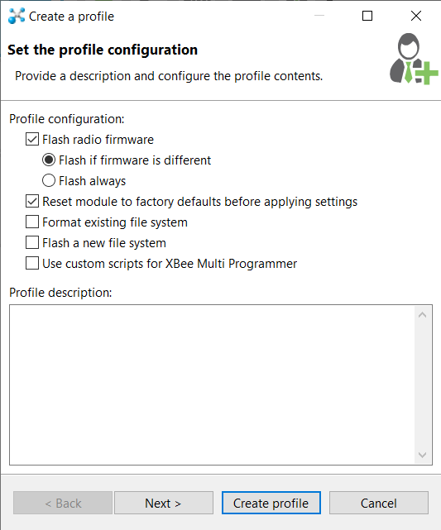

Press **Next** three times, then select **Create profile**. **Rename** this profile to match the device type, then **save** it to your lab folder.

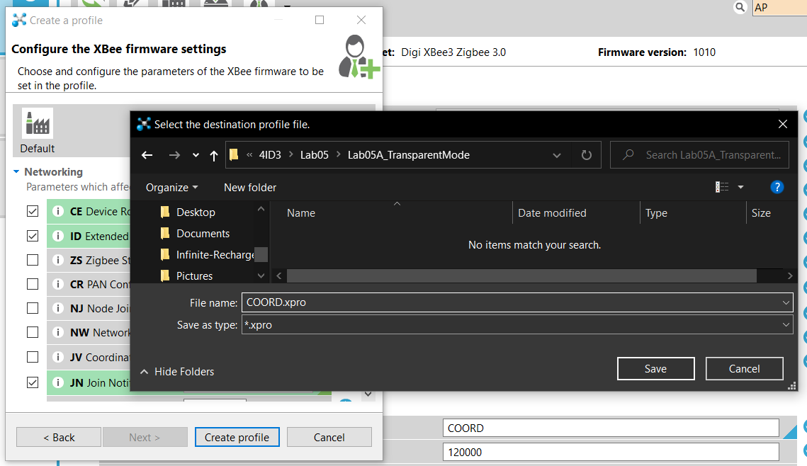

Repeat for each device.

# API Mode

Navigate to the XCTU configure and modify the **AP** parameter in each device’s configuration.

Modify **AP 0 (transparent) -> AP 1 (API mode without escape).**

Press **Write**.

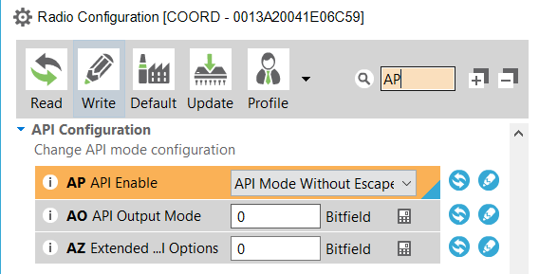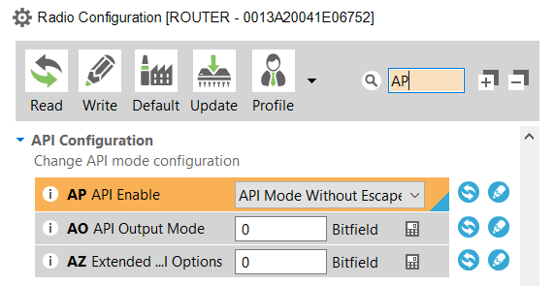

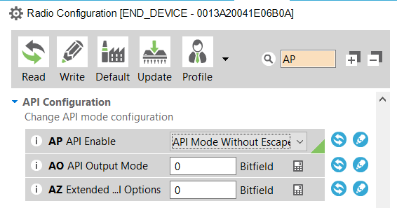

To verify that the network has been established correctly, navigate to **COORD** > **Networks tab** (top right).

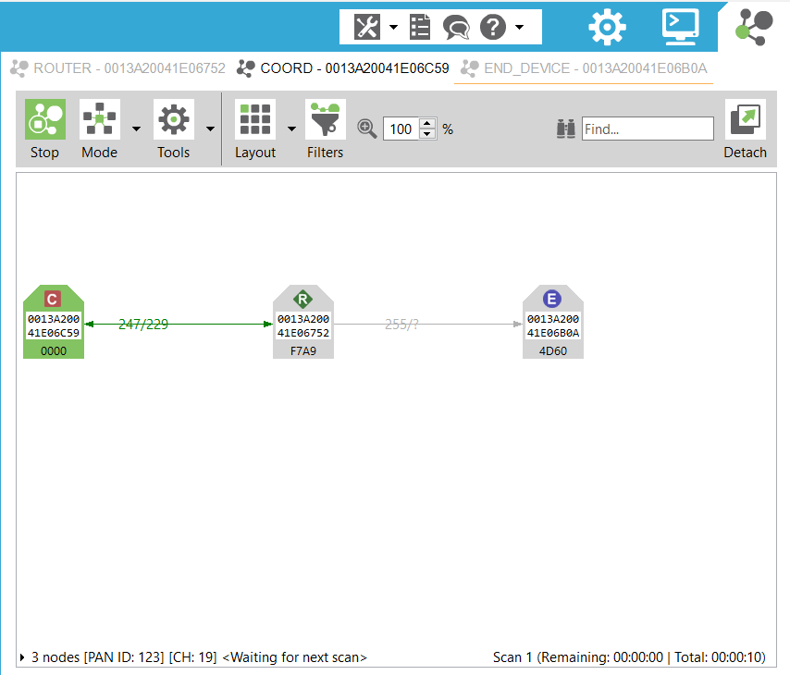

In the **ROUTER** device, create a new packet.

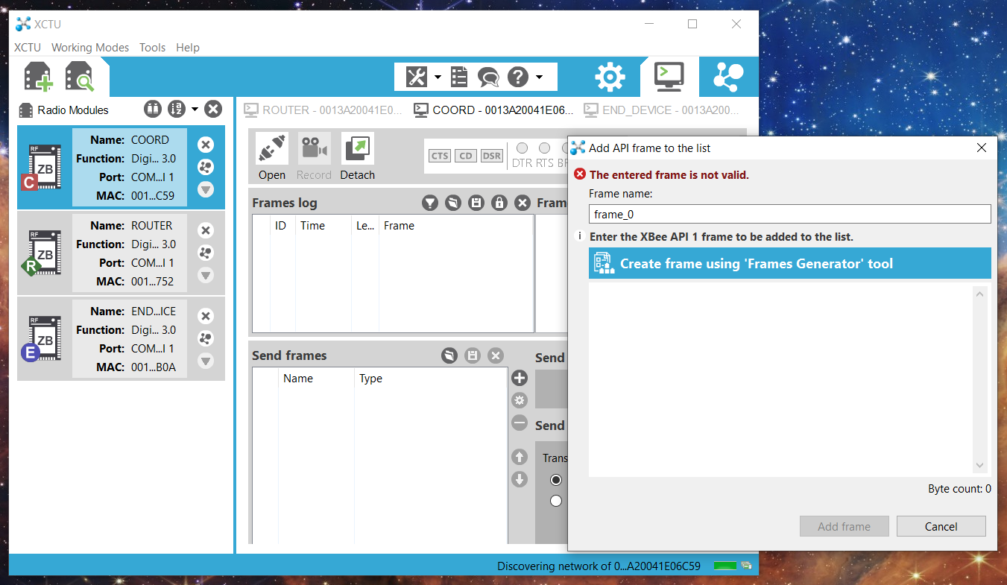

**Select** 0x10 **– Transmit Request** as the frame type. In the **address** field, ensure that it is 0x00. This is the automatic address for the coordinator device on the network. Lastly, type some ASCII characters in the **RF data** field.

Press **OK** to add the new frame.

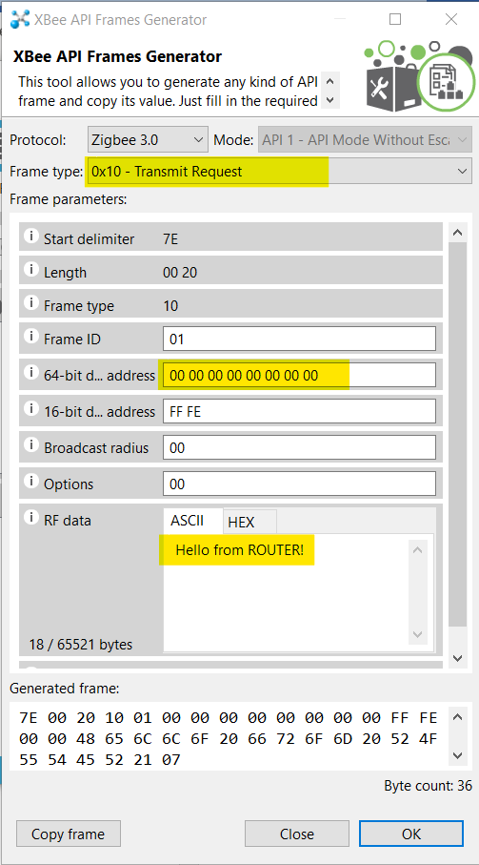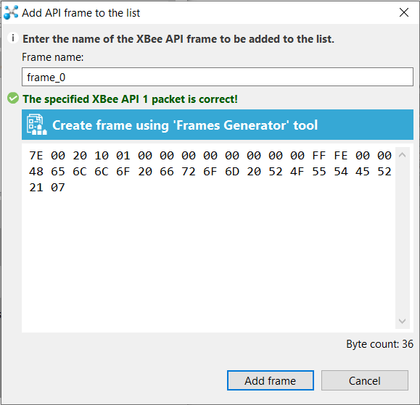

Open both the **ROUTER** and the **COORD** devices in separate console windows. Transmit the packed from the **ROUTER** to the **COORD**. Ensure that it arrives correctly, and an **OK** status is received on the **ROUTER**.

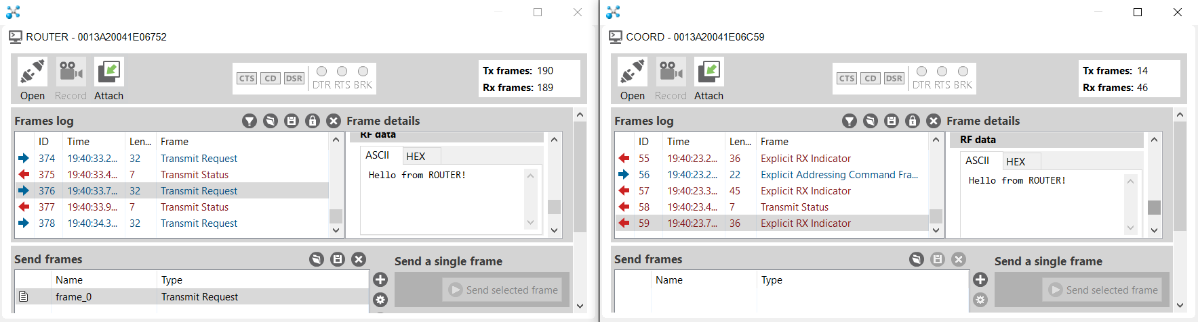

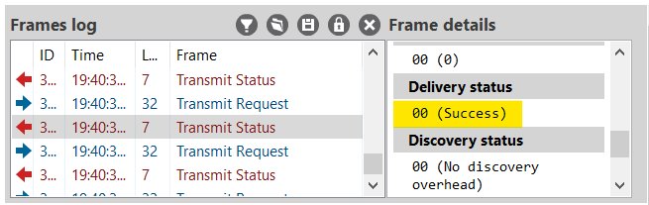

Next, open both the **END_DEVICE** and **ROUTER**. Create a packed for the END_DEVICE to transmit and set its destination address to the ROUTERS MAC address.

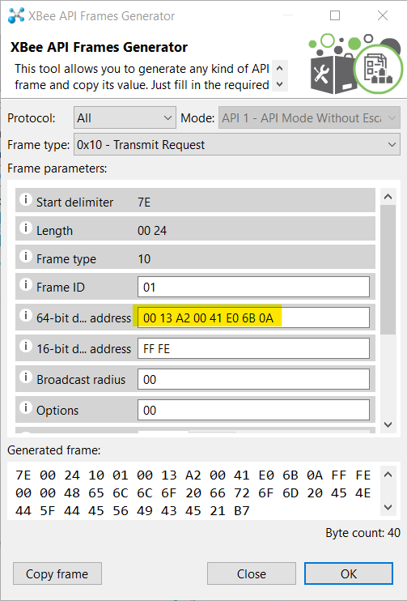

Send the packet.

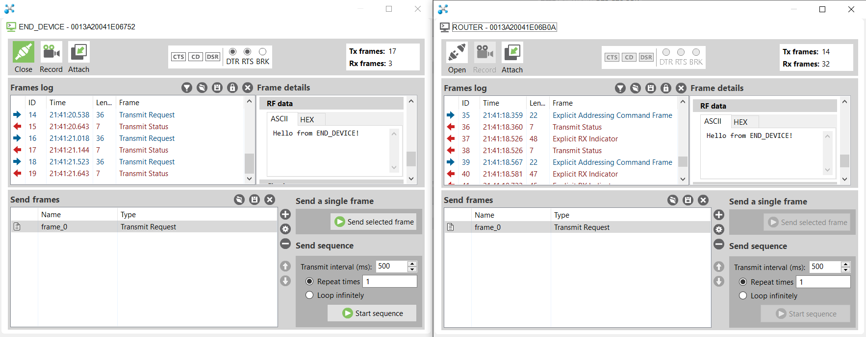

You will see that the data has been sent to the ROUTER.

Now, modify that packet to contain the destination address 00 00 00 00 00 00 00 00.

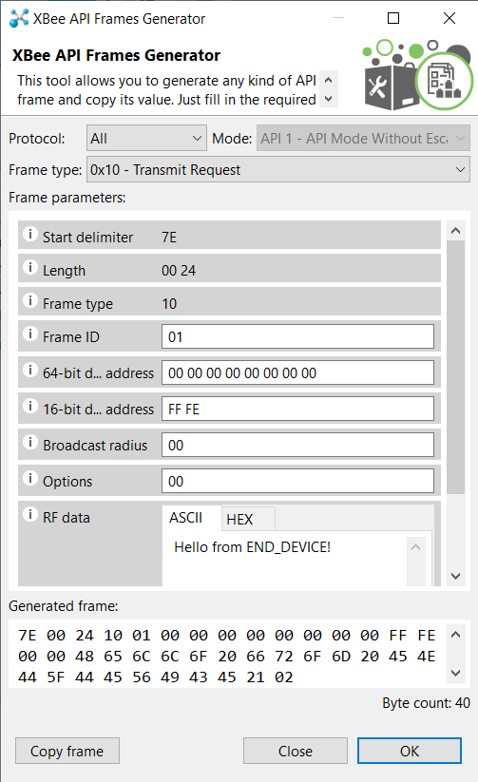

Save and transmit this message. Observe that **on END_DEVICE wake**, the data is transmitted to the **COORD** device.

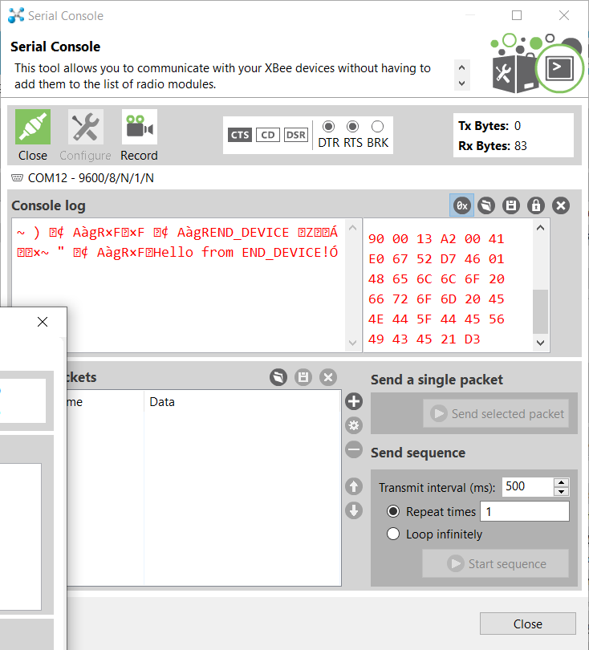

Create a new folder in your lab called **Lab05B_APIMode**.

Generate and export your profiles to this folder.

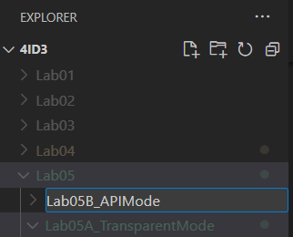

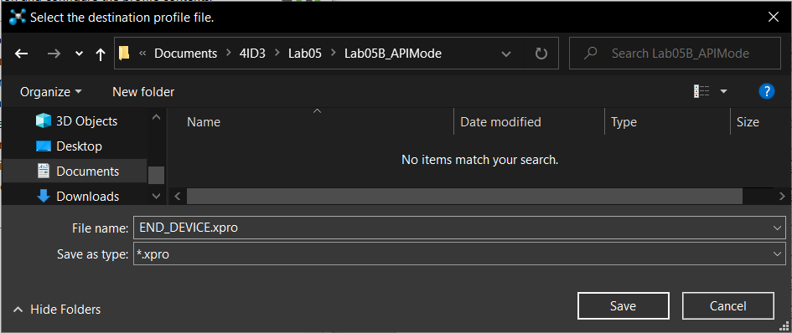

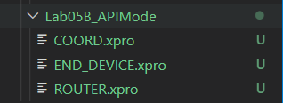

# GPIO Forwarding

## Connections

Make all connections on the **ROUTER** development board.

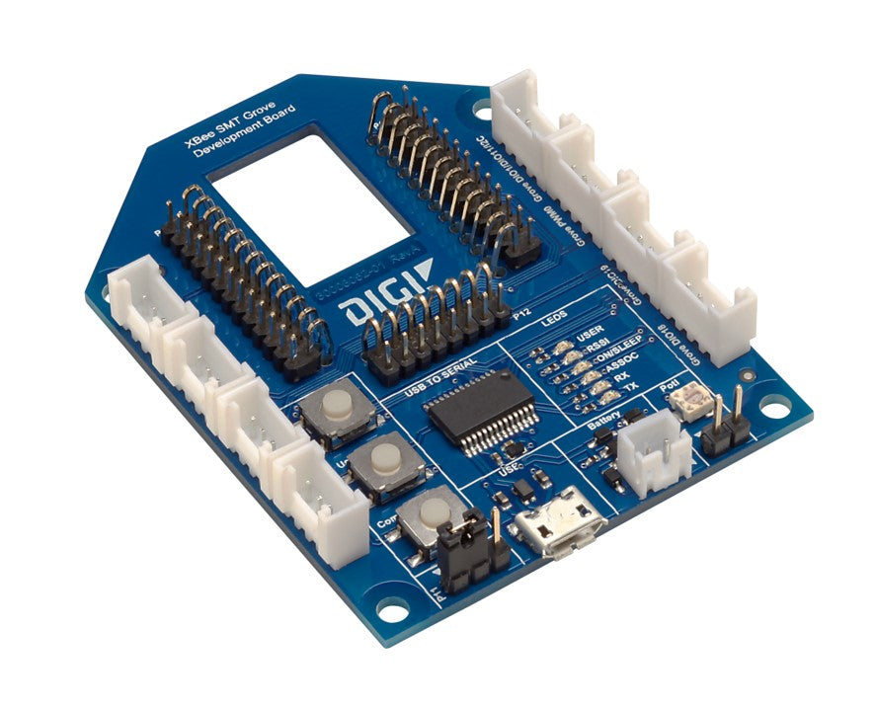

Potentiometer

User Button

JST SM v2 Connector

GPIO3

JST SM v2 (Grove) connector pinout:

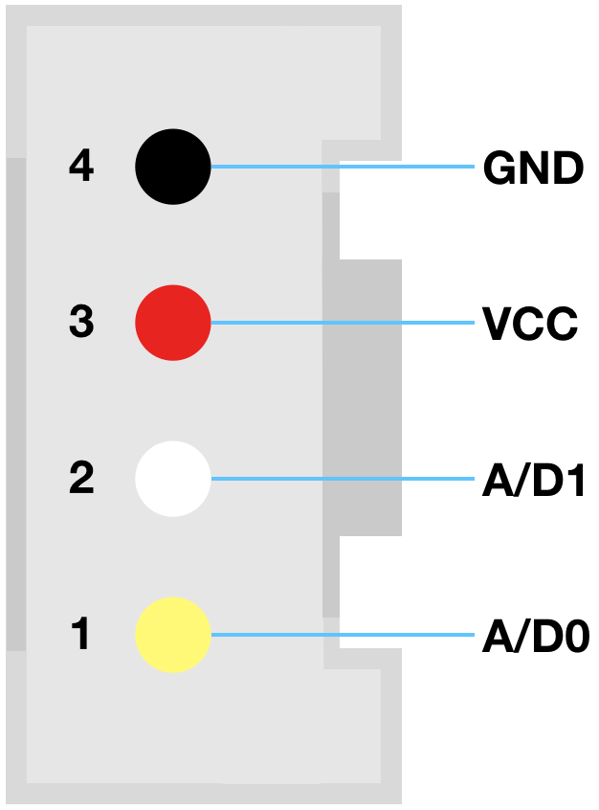

Wiring Diagram:

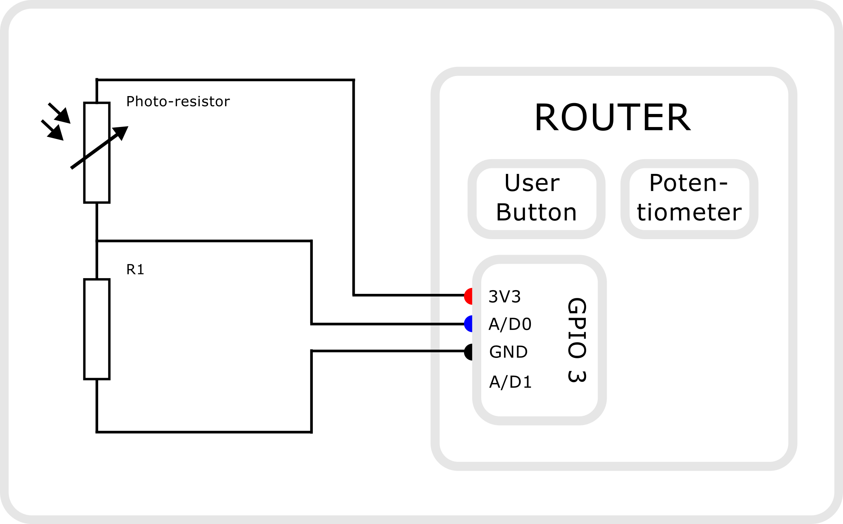

## Python script setup

Create a new folder in your project folder called **Lab05C­_GPIO**.

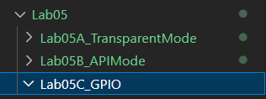

Inside of **Lab05C_GPIO**, create a new folder called **Scripts**.

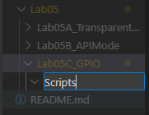

Inside of **Scripts**, create a new virtual environment and source that virtual environment.

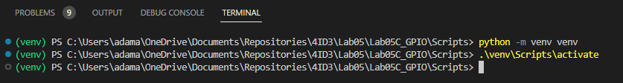

First, lets start off by installing the required libraries:

*paho-mqtt*

*digi-xbee*

*mysql-connector-python*

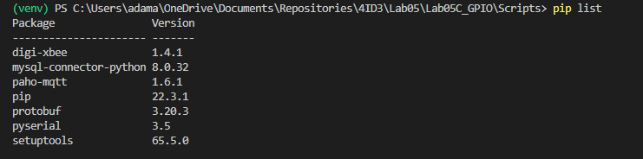

Freeze the libraries into a requirements.txt file:

*pip freeze > requirements.txt*

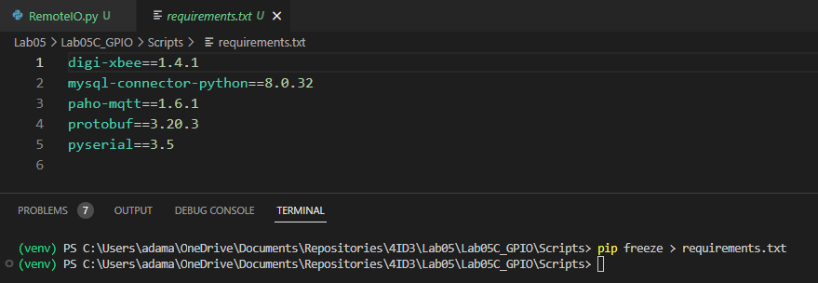

Create a new Python script named **RemoteDIO.py**.

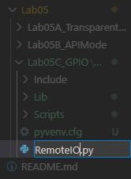

Inside this blank script, paste in the provided example template.

<https://github.com/sokacza/4ID3/blob/main/Lab05/Lab05C_GPIO/Scripts/RemoteIO.py>

Change the configuration parameters at the top of the file. Use the **PORT** of the **COORDINATOR** device.

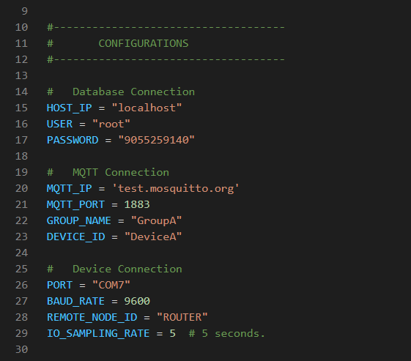

The first thing we have is a dictionary that stores what sensors are on which GPIO, what the name is, and what type of GPIO it is.

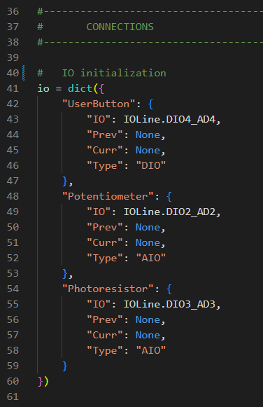

In the class, there is a **parse** method that looks at the raw string returned by the **digi-xbee** library.

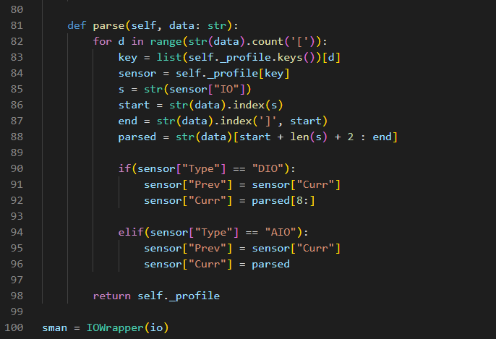

This breaks up the string depending on how many items there are and updates the current and previous values of the dictionary.

Each time the script runs, the database is **reset** and MQTT is connected to.

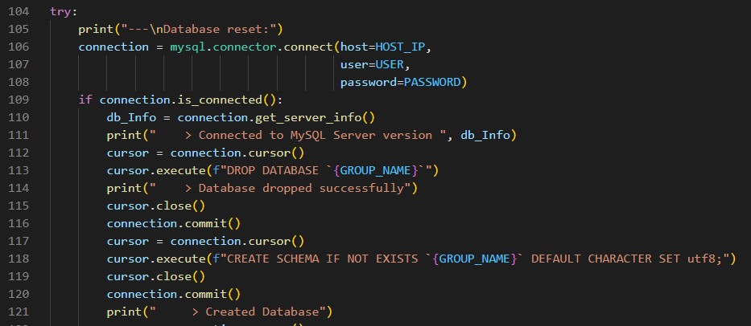

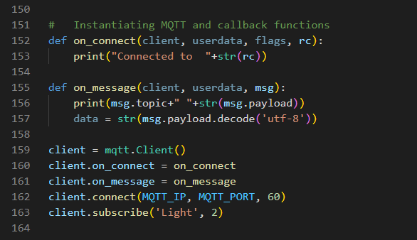

Lastly, the main method handles all the setup required.

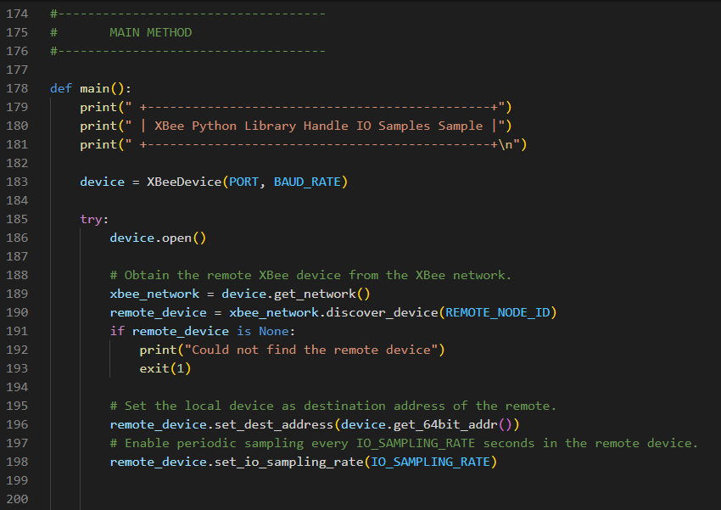

For each sensor reading parsed out of the string, we insert a database entry and publish to an mqtt topic.

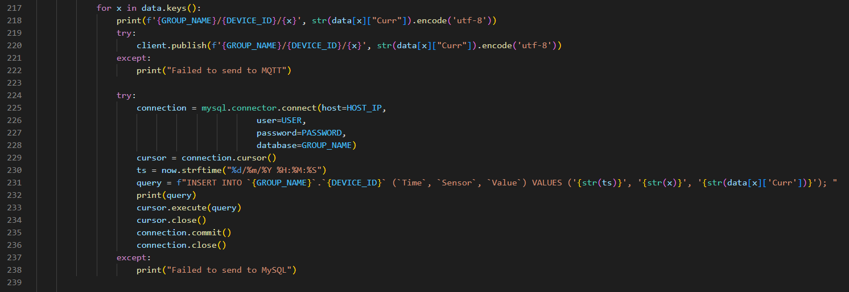

Finally, run the Python script:

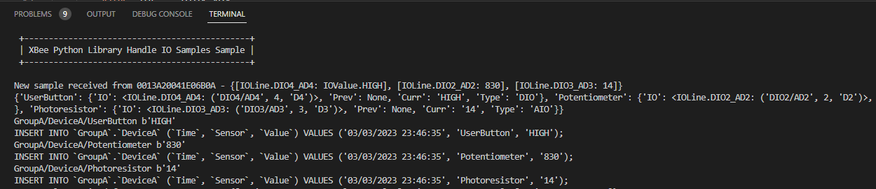

Click your button change your potentiometer, and cover your photoresistor as data is being collected.

And check your database:

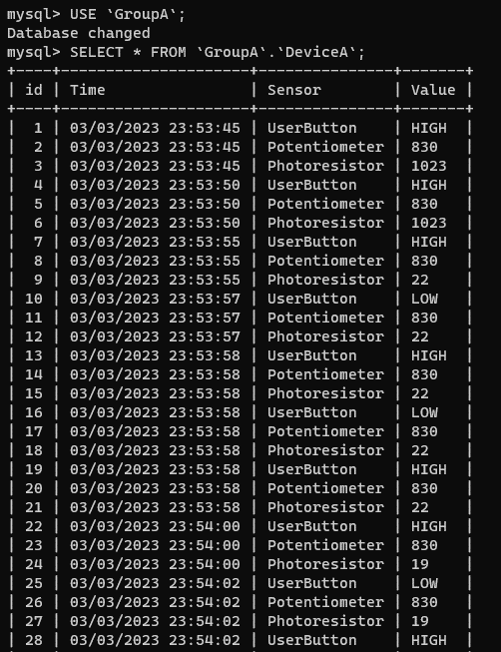

# Exercise A

Use NodeRED to create a dashboard and visualize the data. Submit a screenshot with your report.

# Exercise B

**Can be done at home.** Either modify the original code or create a separate Python script to export the data to an CSV file. Graph each sensor as its own graph. Submit those 3 screenshots with your report.

*Hint: Look at the previous lab*

# (Optional) Exercise C

**Can be done at home.** Create a .Net WinForms desktop application to query the database and display the data. A template has been provided in the lab GitHub. Submit a screenshot with your report.

# Syncing with GitHub

Use the following commands to resync your Git repo with your GitHub remote repo.

*git add .*

*git commit -m “Lab 04 completed”*

*git push origin main*

*git pull origin main*

|  |
| --- |
| END |